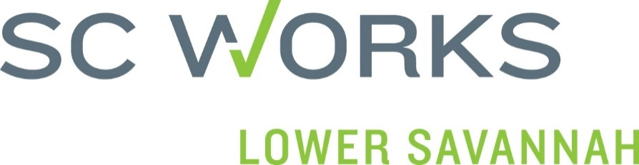

Calhoun SC Works will be hosting a Calhoun County Job Fair! This free event, sponsored by Lower Savannah Council of Governments, SC Works & local partnering agencies, will be held at the John Ford Community Center on Wednesday, November 17, 2021 from 10:00 am to 2:00 pm. Set up for employers will start between 9:00 am – 09:45 am.
Please register by November 5th to ensure your space, as space is limited.
Take advantage of this FREE opportunity to fill your vacancies. We look forward to you and your business being a part of our Calhoun County Job Fair!
Thank you and send in your Registration Form Today!
RSVP to: wmahuron@lscog.org
---------------------------------------------------------------------------------------------------------------------------------------
CALHOUN COUNTY JOB FAIR REGISTRATION FORM
WEDNESDAY, NOVEMBER 17, 2021

Business/Company Name: Click or tap here to enter text.
Address: Click or tap here to enter text.
Contact Name: Click or tap here to enter text.
Phone #: Click or tap here to enter text. Email Address: Click or tap here to enter text.
Company Website/URL: Click or tap here to enter text.
# of Representatives Attending: Click or tap here to enter text.
List of Current Available Positions:
Click or tap here to enter text. # of openings Click or tap here to enter text. FT ☐ PT ☐
Click or tap here to enter text. #of openings Click or tap here to enter text. FT ☐ PT ☐
Click or tap here to enter text. # of openings Click or tap here to enter text. FT ☐ PT ☐

EMPLOYERS SHOULD BE REGISTERED WITH SC WORKS – https://scworks.org/

